**Assignment 7-Docker**

**Step 1.** Create your image with Dockerfile.

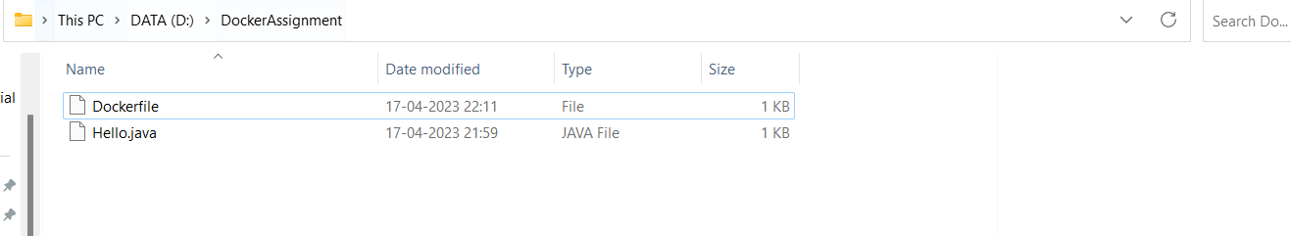

**Step 2.** Build and deploy your application in the Docker.

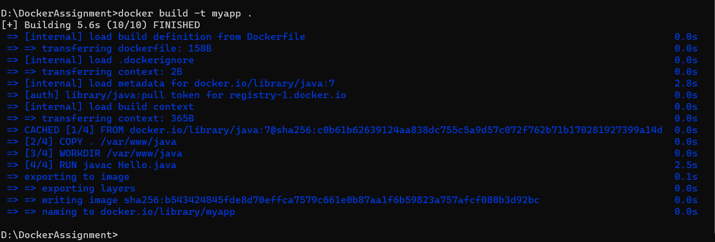

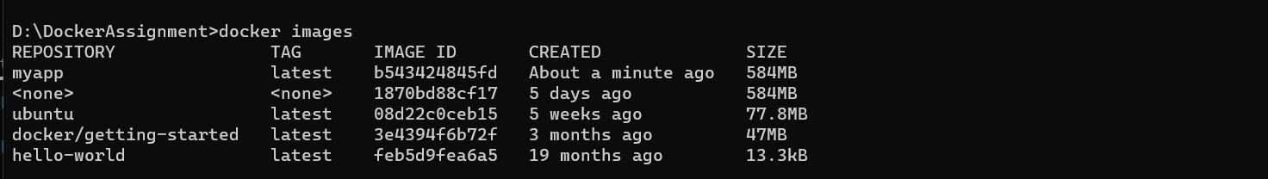

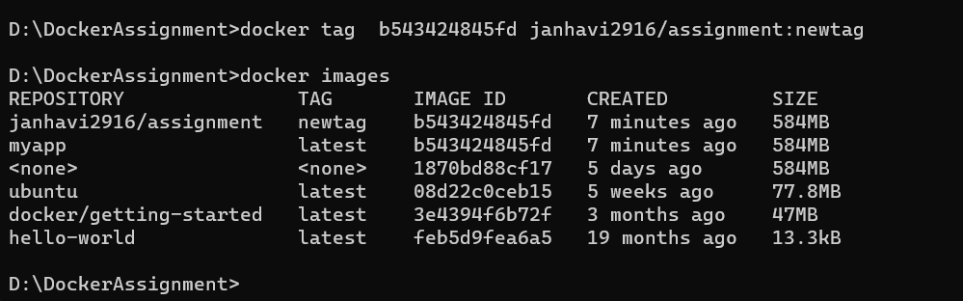

**Step 3.** Push your image into Docker hub as public repository.

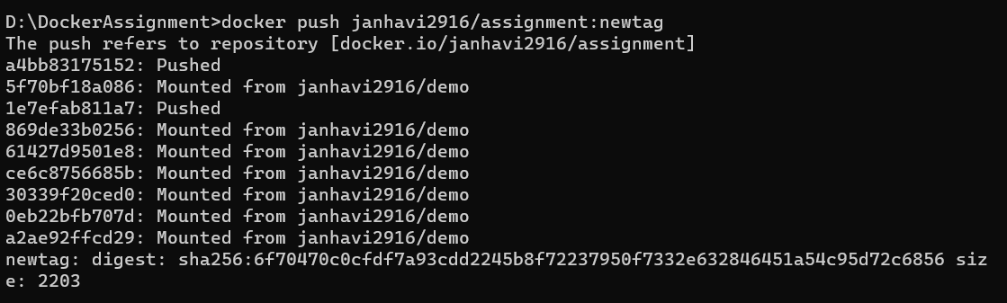

**Step 4.** Run the commands on Docker terminal

• Docker pull

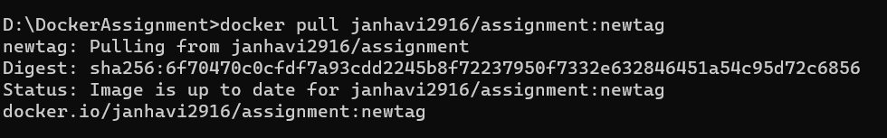

• Docker images

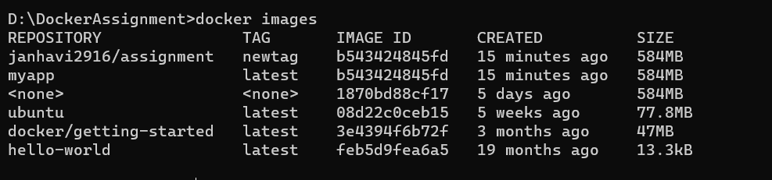

• Docker run



• Docker commit & docker ps

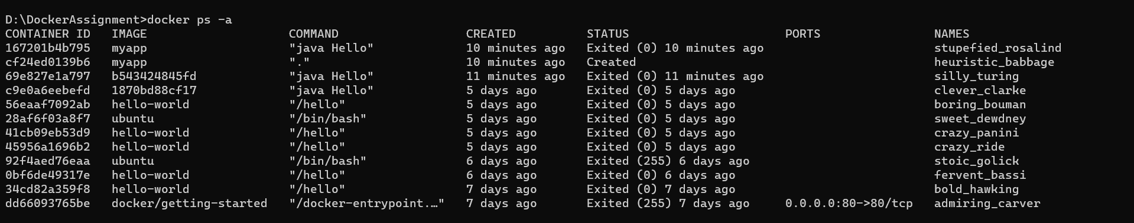



• Docker stop

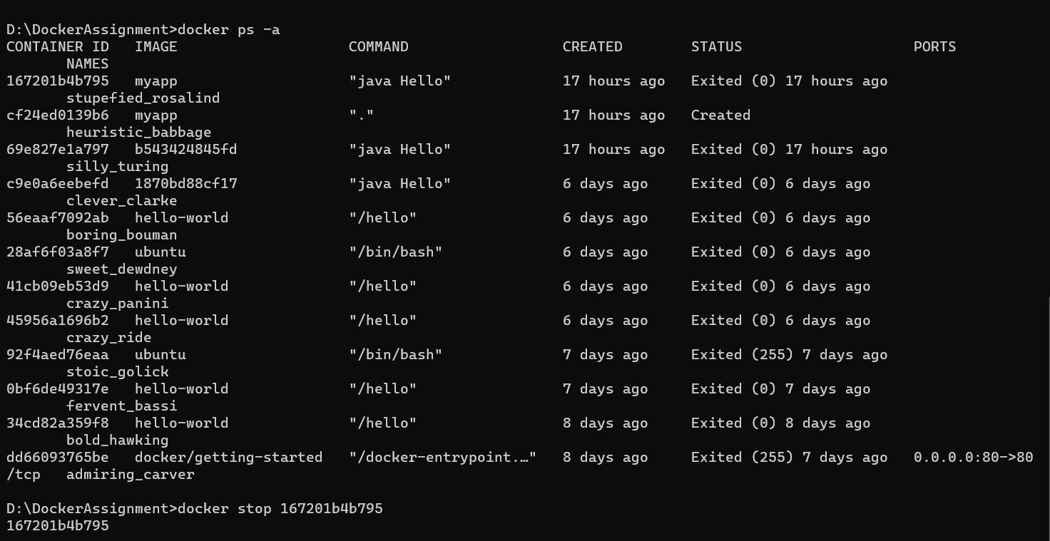

• Docker rm

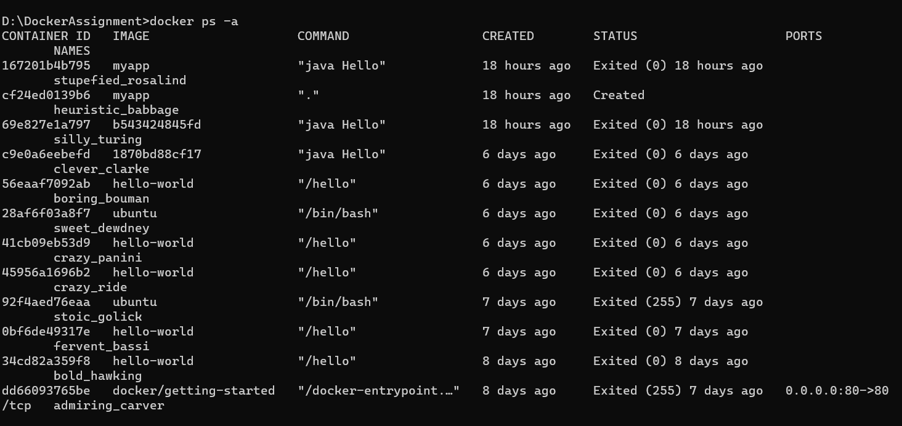



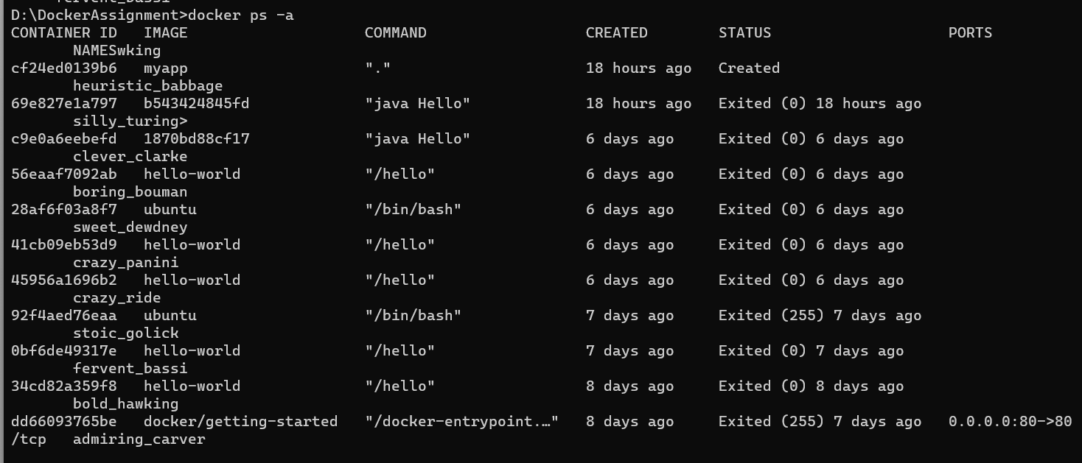

• Docker rmi

